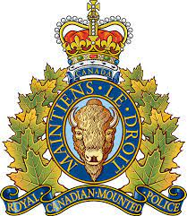

The Wakaw RCMP cordially invites you to an open house to be held on May 17th, 2023 in celebration of Police Week.
The event will be held at the Wakaw Legion, 314 3rd st. South in Wakaw, SK from 6:00pm to 8:00pm.
RCMP will be on hand to answer questions and demonstrate some of our equipment.
Refreshments will be provided.
All citizens are welcome to attend.

Sincerely;
Sgt. Adam Von Niessen
Detachment Commander

